**Chapter 3: Where Prices Come From: The Interaction of Demand and Supply**

One of the last things mentioned in the previous chapter is that that for a market to work as efficiently as possible, prices must be allowed to increase and decrease unimpeded. Why must prices be allowed to freely fluctuate? What do prices do for market participants? Prices send signals to the market participants on how to allocate their scarce resources. When prices are allowed to fluctuate freely, market participants are incentivized to allocate their scarce resources to their highest valued return. Anything that prevents prices from moving freely, or alters their true equilibrium price, market efficiency will decrease. This will be proven in the following chapter.

This chapter will introduce the economic model of supply and demand. This model can be used to understand why prices change, and how prices affect quantity demand and quantity supply. The chapter will then look at factors other than price that can impact the market, and how the market will respond to these changes.

The supply and demand model assumes that the market being analyzed is perfectly competitive.

**Perfectly Competitive Markets**

* Many buyers and sellers
* All firms are selling identical products
* No barriers preventing new firms from entering the market.

This model can then be used to understand the other market structures; monopolistically competitive markets, oligopolistically competitive markets, and markets with a single firm, a monopoly. Those different market structures and how firms behave in them will be covered later in the text. Each in their own capacity.

Before understanding how the model works, an understanding of the underlying principals must first be accomplished. The chapter will first cover the demand side of the model and then it will cover the supply side of the model. After a firm understanding of each side of the model has been achieved, the chapter will cover how the model works.

**Demand Side**

* What is it?
* How does it work?
* What changes demand/quantity demand?
* Is the relationship between price and quantity positive or negative?

Last chapter it was uncovered that consumers ultimately determine which goods and services will be produced in market-based economies. Since this is the case, the most successful businesses are those that can adapt the quickest to changes in how consumers allocate their scarce resources. Firms need to be in constant awareness of this if they wish to remain successful.

Demand consists of two factors; want and ability. Everyone wants everything, but due to scarcity everyone cannot have everything. Most people would love to have their own private island, however, most do not. They have the want, but not the ability. They have yet to figured out how to turn their scarce resources into higher multiples.

**Law of Demand** - The rule that, holding everything else constant, when price decreases quantity demanded will increase, and when price increases quantity demanded will decrease. Due to the inverse relationship between price and quantity the demand curve will have a negative slope.

Think about it at an individual level. An individual is accustomed to paying $3.50 per gallon of gas. They are about to pump their gas and realize that the price on the pump says $1.00 per gallon. It is likely that the individual will purchase more gallons of gas than they otherwise would have. The price went down, and the quantity demanded went up.

Price and quantity have an inverse relationship because of two economic effects. The substitution effect and the Income effect. These two effects are in effect simultaneously.

**The Substitution Effect –** the change in quantity demanded of a good/service that results from a change in price, making the good more or less expensive relative to other goods that are substitutes.

Example: Pepsi vs. Coca-Cola. If Pepsi’s price decreases, it becomes cheaper relative to Coca-Cola. This results in an increase in the quantity demanded for Pepsi and a decrease in quantity demanded for Coca-Cola.

**Income Effect –** The change in the quantity demanded of a good/service that results from the effect of a change in the good’s price on a consumer’s purchasing power. If the price of a good/service increases or decreases a consumer can either buy more or less of that good because their income is limited. If the price of a good/service decreases it would increase a consumer’s purchasing power, and if the price a good were to increase, then the consumer’s purchasing power would decrease.

Example: A consumer has a $1,000 income. The good being purchased is $100, and therefore, they can buy 10 units, but if the price were to decrease to $50 they could buy 20 units. Purchasing power has increased as a result of the lower price.

*At a given moment a consumer’s income is fixed. Therefore, their purchasing power is fixed. However, if the price fluctuates than so does the consumer’s purchasing power even though their income is fixed.

**These two items act simultaneously. Price of pizza decreases, consumer buys more because it becomes cheaper relative to substitutes for pizza and because the consumers purchasing power has increased.**

**Demand Schedule** - a table of prices and quantities with an inverse relationship.

|  |  |
| --- | --- |
| **Demand Schedule** | |
| Price | Quantity |
| $1,000 | 100 |
| 800 | 150 |
| 600 | 200 |
| 400 | 250 |
| 200 | 300 |

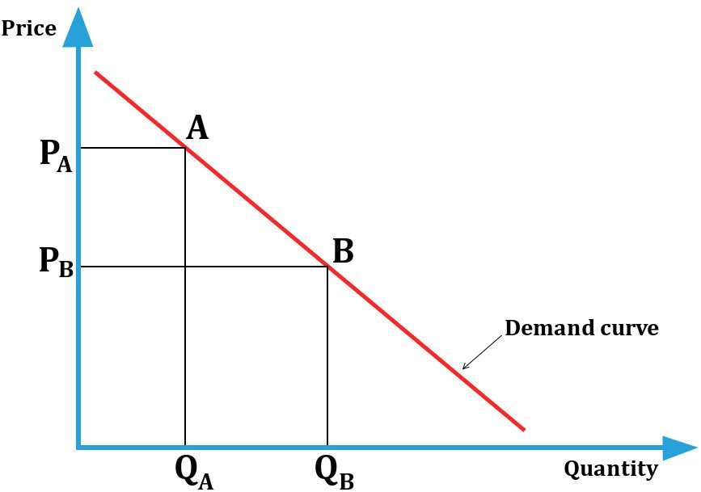

Demand curves in this chapter will reference market demand curves. Individual firm’s demand curves will be covered later in the text. Demand curves are easier to work with when they are linear, and since this is an introductory text, they will remain that way. Real demand curves are non-linear, but what is covered in this chapter can easily be applied to non-linear demand curves.

**Market Demand** – The demand by all consumers of a given good or service in a specified region.

When working with demand curves always be cognizant of the market being analyzed. How many consumers are in it, and the geographical area being covered.

The law of demand holds true for any market demand curve; economists have only found a few exceptions to the law and those will not be covered.

**Side Note**

The law of demand contains the phrase *everything else constant.* Economists use the Latin term Ceteris Paribus interchangeably with this phrase. It is important to hold this true as the supply and demand model is being used. When analyzing the relationship between variables – such as price and quantity demanded – all other variables must be held constant. Only one variable can change at a time, and all others must be kept constant. Once one variable changes, then another can be changed, and then another, and so on. Sequential order Analyzation.

**Differences between Demand and Quantity Demand**

It is extremely important to note and understand that there is a difference between Demand and Quantity demanded.

**Demand –** Represents the aggregate amount demanded at a single given price. When there is a change in demand it is caused by changes in variables other than price. When demand changes, price remains constant and the demand curve will shift to the right or to the left. Graphically, an increase in demand is seen as a shift right of the demand curve, and a decrease in demand is seen as a shift left of the demand curve.

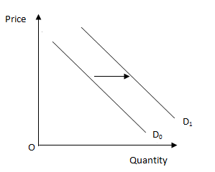

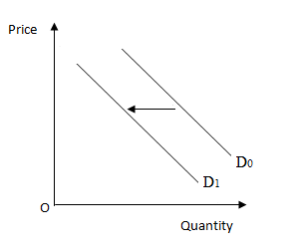

*An increase in demand A decrease in demand*

**Quantity Demanded** –Represents a specific quantity, at a specific price. Changes in quantity demand result when there is a change in price, while all variables remain constant. Graphically, changes in quantity demand are seen as movements along the original demand curve. If price increases and there is a decrease in quantity demand, movement will be upward and to the left along the original demand curve. If price decreases and there is an increase in quantity demand, movement will be downward and to the left along the original demand curve.



Example: If price increases from point B to point A, there will be movement along the demand curve upward and to the left. If price decreases from point A to point B, there will be movement along the demand curve downward and to the right.

**Demand Curve Shifters**

Remember that shifts of the demand curve result when price remains constant and some other variable changes. There are five variables that can shift the demand curve.

**Shifters of Demand**

1. Price of related goods
2. Income
3. Population and demographics
4. Expected future prices
5. Tastes

A good way to remember the shifters of demand is to place them in the above order to create the acronym P.I.P.E.T; a measuring instrument that is used to measure small precise amounts of liquid.

If you can remember this acronym than you will have a head start on remembering the five shifters of demand, but to be able to use them properly you will know how they work. Another good way of remembering the five demand shifters is to make up a mnemonic. An example of a mnemonic that can help you remember the demand shifters is “Please Include Pie Every Tuesday”.

The chapter will now discuss how the five demand shifters work, diving into each one individually.

1. **Prices of related Goods** -the prices of goods/services other than the good/service in question can influence the consumer’s demand for a product. Three relationships can exist between goods/services; they can be substitutes to each other, complimentary to each other, or they can be unrelated.

**Substitutes** - Goods/services that can be used for the same purpose.

Ex: Pen and Pencil can be considered substitutes one another as they both can accomplish the task of writing. If the price of pencils increase, the **quantity demand** of pencils will decrease. However, people still need to be able to write, and therefore, **demand** for pens will increase without the price of pens increasing.

Both the pencil and pen markets will be affected. The market demand curve for pencils will experience a **movement** upward and to the left along its original demand curve because of the increase in price, and the market demand curve for pens will experience a **shift** to the right because the price of pencils increased.

**Rules for substitutes**

1). If the price of A increases (movement left), the demand for B will increases (shift right).

2.) If the price of A decreases (movement right), the demand for B will decreases (shift left)

*There is positive relationship between the price of A and the demand of B when the goods/services are substitutes.

***Insert appropriate graphs here***

**Compliments** –goods and services that are used together.

Ex: Gasoline and Automobiles are considered complimentary goods because they are used together, unless the automobile is electric. If the price of gasoline increases the **quantity demand** of gasoline will decrease. However, automobiles need gasoline to run, and therefore, the **demand** for automobiles will decrease without the price of automobiles decreasing.

Both the gasoline and automobile markets will be affected. The market demand curve for gasoline will experience a **movement** downward and to the right along its original demand curve because of the decrease in price, and the market demand curve for automobiles will experience a **shift** to the left because the price of gasoline increased.

**Rules for Compliments**

1). If the price of A increases (movement left), the demand for B will decrease (shift left).

2.) If the price of A decreases (movement right), the demand for B will increase (shift right)

*There is negative relationship between the price of A and the demand of B when the goods/services are compliments.

***Insert appropriate graphs here***

1. **Income –** the income (resources) a consumer has available to spend affects their willingness and ability to buy a good or service without the price of the good/service changing.

Before one can understand how income can change demand. One must understand the differences between **Normal** goods/services and **Inferior** goods/services.

**Normal Goods/Services** – goods and services that have a positive relationship between income and demand. If overall incomes increase, demand will increase (shift right). If overall income decreases, demand will decrease (shift left)

***Insert appropriate graphs here***

**Rules for Normal Goods/Services**

1. If overall incomes increase, demand will increase (shift right).
2. If overall incomes decrease, demand will decrease (shift left).

*There is a positive relationship between income and normal goods/services.

Examples of normal goods/services: internet, automobiles, food, etc.

**Inferior Goods/Services** – goods and services that have a negative relationship between income and demand. If overall incomes increase, demand will decrease (shift left). If overall incomes decrease, demand will increase (shift right).

***Insert appropriate graphs here***

**Rules for Inferior Goods/Services**

1. If overall incomes increase, demand will decrease (shift left).
2. If overall incomes decrease, demand will increase (shift right).

*There is a negative relationship between income and inferior goods/services.

Examples of inferior goods/services: Spam (meat in a can), Ramen Noodles, Fast Food, etc.

**3.) Populations and Demographics**

**Population** – refers to the number of consumers in the market.

**Rules for Population**

1. If population increases, then demand increases (shifts right).
2. If population decreases, then demand decreases (shifts left).

*There is a positive relationship between population and demand.

***Insert appropriate graphs here***

**Demographics** – statistical data relating to the population and particular groups within it.

Examples: Race, Sex, Religion, Educational Attainment, etc.

**Rules for Demographics**

There are no set rules for this demand shifter, each demographical change and market must be analyzed independently.

**4.) Expected Future Prices**

Expected FUTURE prices can influence present demand. Not current prices but expected future prices.

**Rules for Expected Future Prices**

1. If consumers expect the market price to increase in the future, current demand will increase (shift right).
2. If consumers expect the market price to decrease in the future, current demand will decrease (shift left)

*There is positive relationship between expected future prices and demand.

**5.) Tastes and Preferences**

**Tastes –** people’s tastes and preferences change, and when they do so will the demand for certain products.

**Rules for Tastes and Preferences**

1. If tastes/preferences move towards a good/service/trend, demand will increase (shift right)
2. If tastes/preferences move away from a good/service/trend, demand will decrease (shift left)

*There is a positive relationship between tastes/preferences and demand.

Advertising is very influential on consumer tastes and preferences, and therefore, is very valuable.

Demand Shifter Recap:

* Purchase of Related Goods: is it a compliment or a substitute?
* Income: is it a normal good or an inferior good?
* Population and Demographics: am I dealing with population or demographics?
* Expected Future Prices: is the price in the future expected to increase or decrease?
* Tastes/Preferences: is the populations taste shifting towards the good/service or away from it?

**Law of Supply –** The rule that, holding everything else constant, when price increases quantity supplied will increase, and when price decreases quantity supplied will decrease. Due to the positive relationship between price and quantity supplied, the supply curve will have a positive slope.

The law of supply has a positive relationship between price and quantity supplied. As price increases, a firm is willing to provide more of that good or service because the good has become more profitable, ceteris paribus. As the price decreases for a particular good or service, the quantity supplied will decrease because the good/service becomes less profitable, ceteris paribus. Profits are the incentive for the firms. The higher the profits the higher their incentive is to supply. The lower their profits the lower their incentive is to supply.

**Supply Schedule** – the table of prices and quantities with a positive relationship.

|  |  |
| --- | --- |
| **Supply Schedule** | |
| Price | Quantity |
| $200 | 100 |
| 400 | 150 |
| 600 | 200 |
| 800 | 250 |
| 1,000 | 300 |

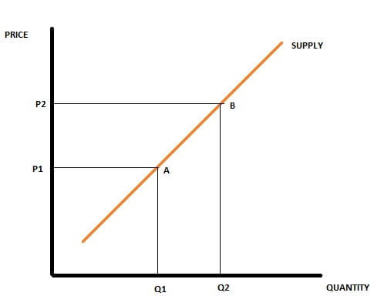

Supply curves in this chapter will reference market supply curves. Individual firm’s supply curves will be covered later in the text. Supply curves are easier to work with when they are linear, and since this is an introductory text, they will remain that way. Real supply curves are non-linear, but what is covered in this chapter can easily be applied to non-linear supply curves.

**Market Supply** – The supply by all firms of a given good or service in a specified region.

When working with supply curves always be cognizant of the market being analyzed. How many firms are in it, and the geographical area being covered.

The law of supply holds true for any market supply curve; economists have only found a few exceptions to the law and those will not be covered.

**Side Note**

The law of supply contains the phrase *everything else constant.* Economists use the Latin term Ceteris Paribus interchangeably with this phrase. It is important to hold this true as the supply and demand model is being used. When analyzing the relationship between variables – such as price and quantity supplied – all other variables must be held constant. Only one variable can change at a time, and all others must be kept constant. Once one variable changes, then another can be changed, and then another, and so on. Sequential order analyzation.

**Differences between Supply and Quantity Supplied**

It is extremely important to note and understand that there is a difference between Supply and Quantity supplied.

**Supply –** Represents the aggregate amount supplied at a single given price. When there is a change in supply, it is caused by changes in variables other than price. When there is a change in supply, price remains constant, and the supply curve will shift to the right or to the left. Graphically, an increase in supply is seen as a shift right of the supply curve (S1), and a decrease in supply is seen as a shift left of the supply curve (S2).

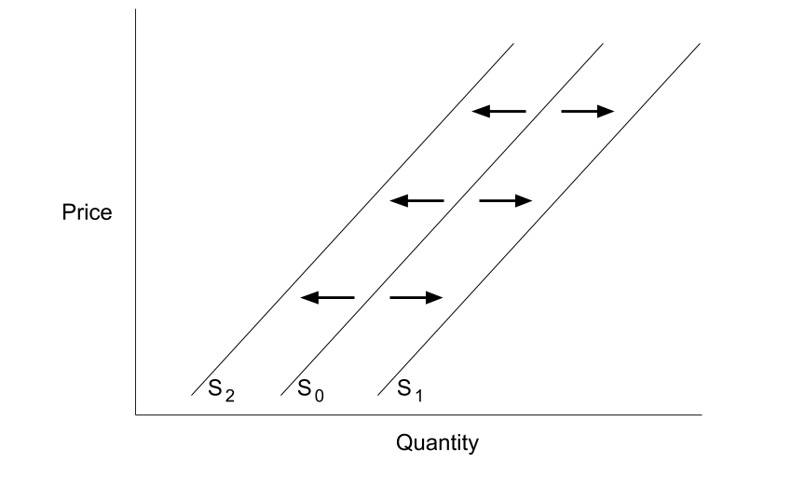

**Quantity Supplied** –Represents a specific quantity, at a specific price. Changes in quantity supplied result when there is a change in price, while all variables remain constant. Graphically, changes in quantity supplied are seen as movements along the original supply curve. If price increases and there is an increase in quantity supplied, movement will be upward and to the right along the original supply curve. If price decreases and there is a decrease in quantity supplied, movement will be downward and to the left along the original supply curve.

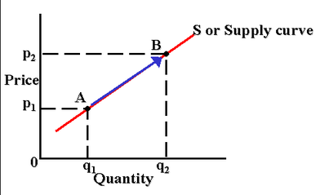

Example: If price increases from point A to point B, there will be movement along the supply curve upward and to the right. If price decreases from point B to point A, there will be movement along the supply curve downward and to the left.

**Supply Curve Shifters**

Remember that shifts of the supply curve result when price remains constant and some other variable changes. There are five variables that can shift the supply curve.

**Shifters of Supply**

1. Price of Inputs
2. Price of Substitutes in Production
3. Expected Future Prices
4. Number of firms
5. Technological changes

A good way to remember the shifters of supply is to place them in the above order to create the acronym P.P.E.N.T; double “P” pent. If you can remember this acronym than you will have a head start on remembering the five shifters of supply, but to be able to use them properly you will know how they work. Another good way of remembering the five supply shifters is to make up a mnemonic. An example of a mnemonic that can help you remember the supply shifters is “Please Play Extremely Nice Together”.

The chapter will now discuss how the five supply shifters work, diving into each one individually.

1. **Prices of Inputs** – Inputs are the goods/services used to produce another good/service. All inputs can fall into one of the four broad categories of the Factors of Production (natural resources, labor, capital, and entrepreneurial skill). This shift results from a change in price of an input. If it is used in the making of the final product, it is considered an input. Prices of inputs have a profound impact on profits, and therefore, will affect the supply of the good/service. If the price of an input increases, profits margins will decrease (ceteris paribus), decreasing the incentive to supply, decreasing supply, and causing a shift left of the original supply curve. If the price of input decreases, profit margins will increase, (ceteris paribus), increasing the incentive to supply, increasing supply, and causing a shift right of the original supply curve.

Example: The price of steel increases. Steel is a major input to producing locomotives. Because of the increase in price of steel, the supply curve of locomotives will decrease (shift left) because they became less profitable (ceteris paribus). Therefore, there will be a movement along the original supply curve for steel up and to the right, and there will be shift left of the original supply curve for locomotives.

**Insert Appropriate Graphs Here**

**Rules for Prices of Inputs**

1. If the price of an input increases, than the supply curve for the output will shift to the left.
2. If the price of an input decreases, than the supply curve for the output will shift to the right.

*There is a negative relationship between the price of an input and the supply of the output.

1. **Prices of Substitutes in Production** – substitutes in production are defined as goods/services that may be produced using relatively the same inputs.

Example: a firm uses labor, capital, wood, glue, nails/screws, saws, steel, and stain to produce wooden desks and wooden fence posts. Therefore, the two goods are substitutes in production for one another.

When the price of a substitute in production changes, relative profit margins also change (ceteris paribus), and therefore, incentives to supply specific goods/services also change.

When the price of a substitute in production increases, ceteris paribus, the profit margin for that good/service increases, increasing the incentive to produce that good/service. Therefore, quantity supplied of that good will increase, however, due to scarcity, in order to produce more of one good less of another must first be produced. Therefore, when the price of a substitute in production increases there will be movement along the original supply curve for that good up and to the right, and a shift to the left (decrease in supply) will occur for the other good. To capitalize on the increased profit margins of the substitute in production, resources must be reallocated from the production of one to the production of another causing the changes in supply without a change in price.

**Insert Appropriate Graphs Here**

**Rules for Substitutes in Production**

1. Increase in price of good/service A, decrease in supply of good/service B (Shift Left).
2. Decrease in price of good/service B, increase in supply of good/service B (Shift Right).

*There is a negative relationship between the price of good/service A and the supply of good/service B when the two goods/services are substitutes in production to one another.

1. **Expected Future Prices** - Expected FUTURE prices can influence present supply. Not current prices but expected future prices.

The goal of producers is opposite that of the consumer. The consumer’s goal is to consume at the cheapest price possible, while the goal of the producer is to sell at the highest price possible, ceteris paribus. Therefore, if producers think the price is going to increase in the future they will restrict current supply in order to supply later at the higher price (shift left). If producers think the price is going to go down in the future they will increase current supply in order to capitalize on the higher price before it goes down (shifts right)

**Insert Appropriate Graphs Here**

**Rules for Expected Future Prices**

1. If firms expect price to increase, current supply will decrease (shift left).
2. If firms expect price to decrease, current supply will increase (shift right).

*There is a negative relationship between the expected future price and the current supply.

1. **Number of Firms** – refers to the number of firms serving the market. Recall there are no barriers to entry, and therefore, firms can enter and exit the market freely. Also remember that there are enough firms that no single firm can impact the market by themselves. This supply shifter behaves just like the demand shifter of population; an increase in population increased demand, and a decrease in population decreased demand. The same relation exists between number of firms and supply. If enough firms enter the market, than the market supply curve will shift to the right. If enough firms exit the market, than the market supply curve will shift to the left.

**Insert Appropriate Graphs Here**

**Rules for Number of Firms**

1. Number of firms increase, supply increase (shifts right).
2. Number of firms decrease, supply decreases (shifts left).

*There is a positive relationship between the number of firms and supply.

1. **Technological Changes** – a positive or negative change in the ability of a firm to produce a given level of output with a given quantity of inputs. Does not necessarily have to do with the Webster’s Dictionary definition of technology.

**Positive Technological Change** – an increase in technology or a change in the process that allows for more output to be produced with the given inputs than previous. It can also be seen as producing the same output as previous using fewer inputs.

**Negative Technological Change** – a decrease in technology or change in the process that decreases the output from the given amount of inputs than previous. It can also be seen as producing the same amount of output as previous using more inputs. Negative technological changes are rare and are usually caused by times of war and/or natural disasters.

**Insert Appropriate Graphs Here**

**Rules for Technological Changes**

1. Positive technological changes, cause an increase in supply (shift right).
2. Negative technological changes, cause a decrease in supply (shift left).

*There is a positive relationship between technology and supply.

**Putting Demand Side and the Supply Side Together**

The supply and demand model is used to predict changes in price and quantity in any given market. It also used to understand why shortages and surpluses exist and how the market works eradicates them.

The intersection of the supply and demand curves on a given model represent market equilibrium. At this intersection, the quantity supplied equals the quantity demanded at a single given price.

**Market Equilibrium** – a situation in which the quantity demanded is equal to the quantity supplied at a single price (Q.S. = Q.D, @ P). When the market is in equilibrium, there is no pressure on price to increase or decrease. When the market is in equilibrium the maximum amount of buyers and sellers are being satisfied. If the market is not in equilibrium, there will be pressure on price to increase or decrease, and there will be fewer satisfied market participants.

When something causes the price in the market to be higher than the equilibrium price a surplus will result.

**Surplus** – a situation in which the quantity supplied is greater than the quantity demanded at a given price (Q.S > Q.D; @P). The number of transactions that will occur in the market is represented by the quantity demanded, since there cannot be more sales than the amount that is being demanded. There are more sellers than buyers at this price. When there is a surplus in the market, there will be downward pressure on price. As price begins to decrease, quantity demanded will increase and quantity supplied will decrease back to the point of equilibrium.

**Insert Appropriate Graphs Here**

When something causes the price in the market to be lower than the equilibrium price a shortage will result.

**Shortage** – a situation in which the quantity demanded is greater than the quantity supplied at a given price (Q.D > Q.S; @P). The number of transactions that will occur in the market is represented by the quantity supplied, since there cannot be more sales than the amount that is being supplied. There are more buyers than sellers at this price. When there is a shotage in the market, there will be upward pressure on price. As price begins to increase, quantity demanded will decrease and quantity supplied will increase back to the point of equilibrium.

**Insert Appropriate Graphs Here**

**Changes in Supply and/or Demand**

Changes in price result from changes in demand and/or supply. When demand/supply change a surplus/shortage will first result. These shortages/surpluses put pressure on price. Price will either have to increase to rid the market of shortage, or decrease to rid the market of the surplus. After the market has adjusted, there will be a new equilibrium price and quantity in the market.

**Demand Only**

**Increase in Demand (shift right)**

When there is a right shift of the demand curve, a shortage will result in the market first. To rid the market of the shortage, price will begin to increase. As price increases, quantity demanded will decrease and quantity supplied will increase to a new equilibrium point. When there is a right shift of the demand curve, the new equilibrium price will be higher, as will the new equilibrium quantity.

**Insert Appropriate Graphs Here**

*When demand shifts right, there will be an increase in equilibrium price and an increase in equilibrium quantity.

**Decrease in Demand (shift left)**

When there is a left shift of the demand curve, a surplus will result in the market first. To rid the market of the surplus, price will begin to decrease. As price decreases, quantity demanded will increase and quantity supplied will decrease to a new equilibrium point. When there is a left shift of the demand curve, the new equilibrium price will be lower, as will the new equilibrium quantity.

*When demand shifts left, there will be a decrease in equilibrium price and a decrease in equilibrium quantity.

**Insert Appropriate Graphs Here**

**Supply Only**

**Increase in Supply (shift right)**

When there is a right shift of the supply curve, a surplus will result in the market first. To rid the market of the surplus, price will begin to decrease. As price decreases, quantity demanded will increase and quantity supplied will decrease to a new equilibrium point. When there is a right shift of the supply curve, the new equilibrium price will be lower and the new equilibrium quantity will be higher.

**Insert Appropriate Graphs Here**

*When supply shifts right, there will be a decrease in equilibrium price and an increase in equilibrium quantity.

**Decrease in Supply (shift left)**

When there is a left shift of the supply curve, a shortage will result in the market first. To rid the market of the shortage, price will begin to increase. As price increases, quantity demanded will decrease and quantity supplied will increase to a new equilibrium point. When there is a left shift of the supply curve, the new equilibrium price will be higher and the new equilibrium quantity will be lower.

**Insert Appropriate Graphs Here**

*When supply shifts left, there will be an increase in equilibrium price and a decrease in equilibrium quantity.

**Simultaneous Shifts**

On rare occasions, there will be situations where the supply and demand curve shift at the same time. When this occurs, the surplus/shortage and the end results associated with the further shifting curve will result.

**Insert Appropriate Graphs Here**

**Supply and Demand Homework Questions**

1. Price must be allowed to freely fluctuate in order for resources to be allocated as efficiently as possible. Why?
2. True or False: When variables other than price change there will be changes in supply/demand. These changes are seen as movements along the original supply/demand curve.
3. An unexpected freeze decreased the supply of oranges for the year. This decrease in supply of oranges has led to the increase in the prices of oranges. Will the increase in price of oranges result in an increase/decrease in supply/demand for apples? In comparison to before the freeze, what will the new equilibrium price and quantity of apples be?
4. The first result of a decrease in demand is a shortage. True/False
5. What is the economic term that describes the inverse relationship between income and demand?
6. Hoodies and t-shirts represents substitutes in production for one another. Explain the reasoning on why an increase in the price of hoodies will result in the decrease in supply of t-shirts.
7. When the price of an input increases, supply for the product decreases. In order to get rid of the resulting shortage, prices must do what?
8. When the price is below the equilibrium price what will occur in the market and must occur in order to eliminate it?
9. When the price is above the equilibrium what will occur in the market and what must occur in order to eliminate it?
10. What will the new equilibrium price and quantity be, compared to the original state, when there is a shift right of the demand curve (after the shortage has been eradicated)?
11. What will the new equilibrium price and quantity be, compared to the original state, when there is a shift left of the demand curve (after the surplus has been eradicated)?
12. What will the new equilibrium price and quantity be, compared to the original state, when there is a shift right of the supply curve (after the surplus has been eradicated)?
13. What will the new equilibrium price and quantity be, compared to the original state, when there is a shift left of the supply curve (after the shortage has been eradicated)?
14. How would the each of the five demand variables (shifters) have to change in order for the demand curve to shift to the right?
15. How would the each of the five supply variables (shifters) have to change in order for the supply curve to shift to the left?